4.5 Sequence Diagram – User Login
Description
The Login Sequence Diagram illustrates the interaction between the user and the system during the authentication process. The user submits login credentials, the system validates the information against the database, and if the credentials are correct, a JWT token is generated and returned to the user. Otherwise, an error message is displayed

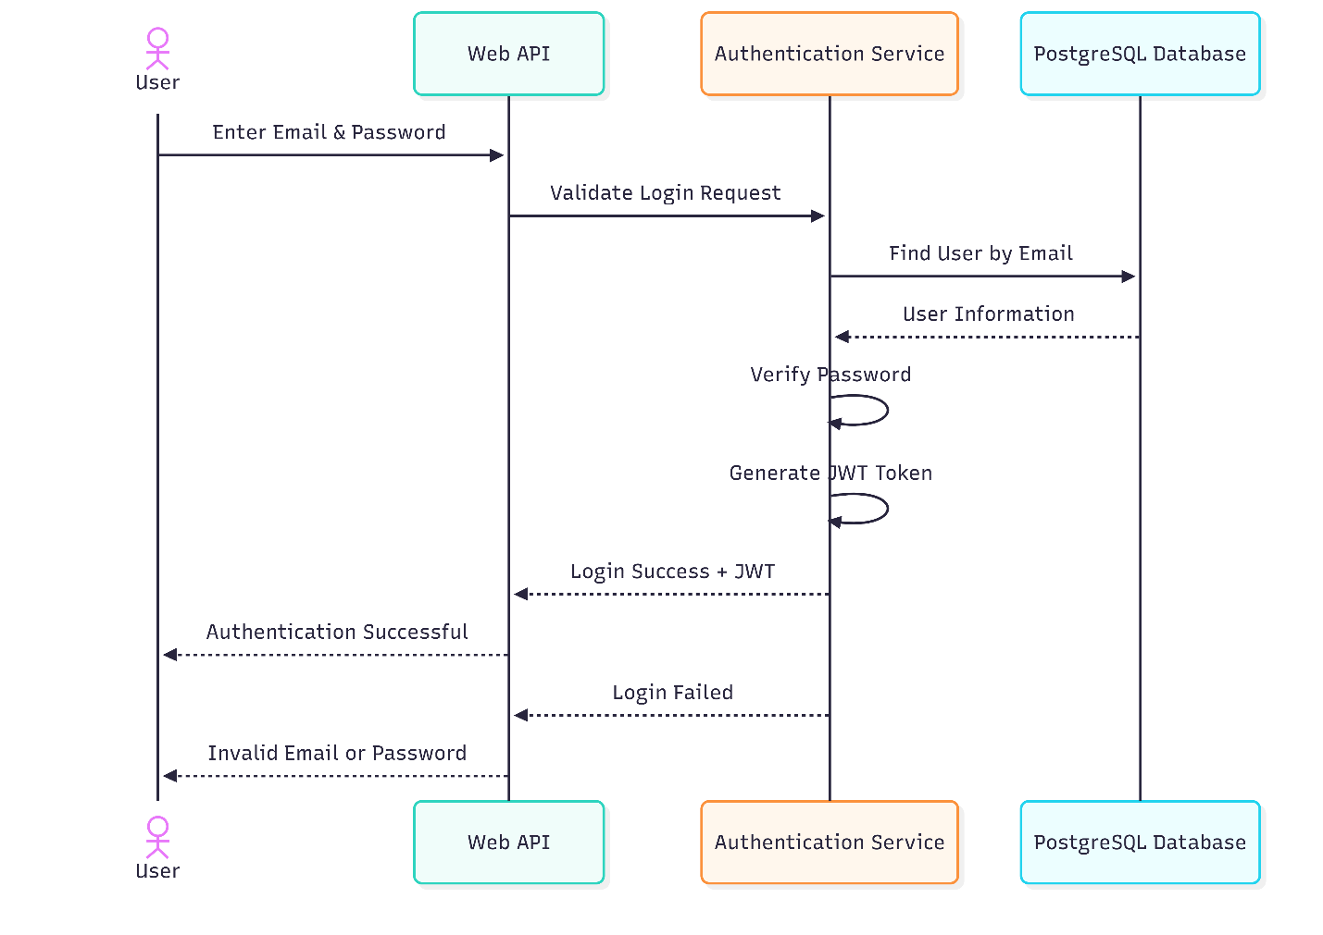

4.6 Sequence Diagram – Book Appointment
Description
The Book Appointment Sequence Diagram illustrates the interaction between the patient and the Dental Clinic Management System when scheduling a new appointment. The patient selects a doctor, service, and preferred date and time. The system checks the doctor's availability, stores the appointment in the PostgreSQL database, and returns a confirmation to the patient.
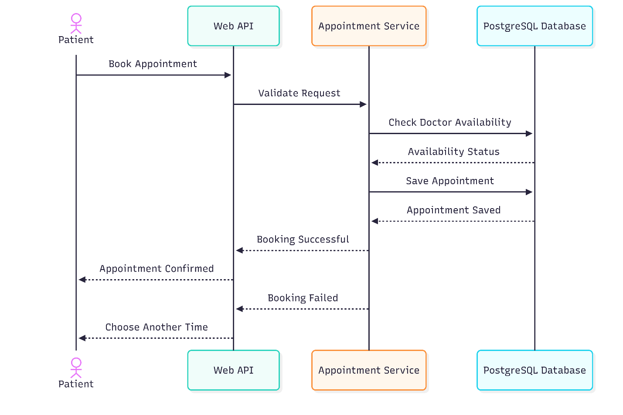

4.7 Sequence Diagram – Create Medical Report & Prescription
Description
The Medical Report and Prescription Sequence Diagram illustrates how the doctor creates a medical report after examining the patient. The report is stored in the database, then a prescription is generated and linked to the report. Finally, the system confirms that both the report and prescription have been saved successfully.
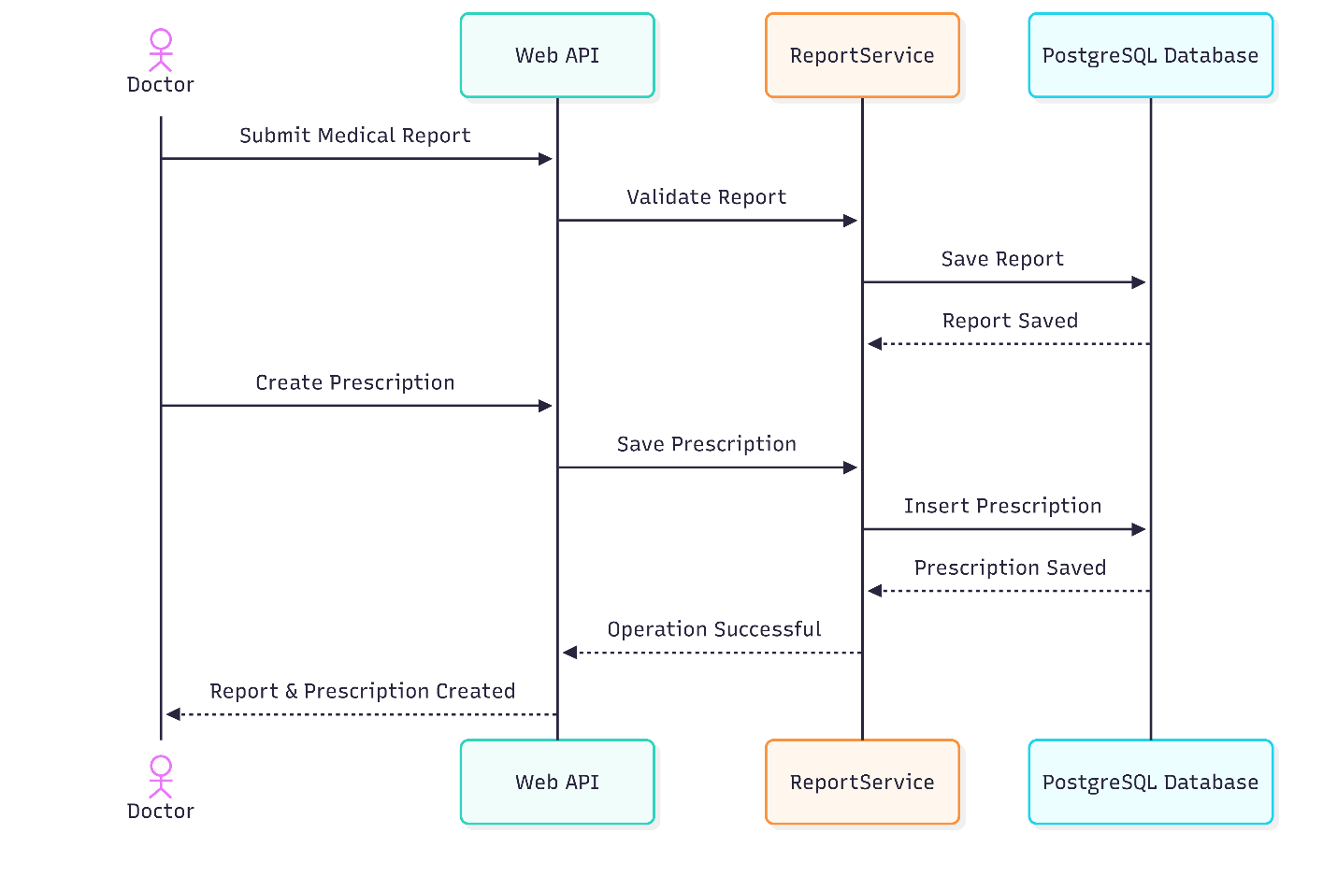

4.8 Sequence Diagram – Manage Appointment
Description
The Manage Appointment Sequence Diagram illustrates how an administrator manages appointment requests. The administrator can confirm, update, or cancel an appointment. The system updates the appointment information in the database and notifies the patient of the final status.
